Room & Resource Reservation Plugin

by

Central Christian Church (AZ)   
www.centralaz.com

with

Taylor Cavaletto, BEMA Information Technologies   
www.bemaservices.com

(formerly of Bricks and Mortar Studio)

# Introduction

So, you’ve gotten the room management plugin. It looks awesome and will help your organization, but you’re a little bit freaked out over all the new stuff. Not to worry, here’s a quick rundown of the new stuff pieces that you’ll have access to.

# Terminology

## Reservations

A *Reservation* is what ties everything in this plugin together. The *Reservation* stores what date and time you are setting aside for your event, how many are attending, and any *Locations* or *Resources* that you’re reserving for those times.

## Locations

When we reserve things for an event we tend to reserve two types of things: rooms and objects. In this plugin, we represent that with *Locations* and *Resources*. A *Location* is a room, along with anything inside that room that cannot be moved, such as wall/ceiling mounted projectors or whiteboards. Since Rock already uses Locations to reflect your organization’s physical room structure for check-in, we use Locations as well. That way you won’t need to enter your room data into Rock a second time. As of 1.4.0, Locations now also have a variety of Layouts that you can configure and select.

## Resources

Unlike a *Location*, a *Resource* is something that can typically be moved from room to room. Tables or chairs are good examples of *Resources*. They also have a concept of quantity, so if you have 150 chairs, you can choose to reserve only 40 of them for an event. Unlike *Locations*, *Resources* are not already in Rock, so you’ll need to add them before you can start reserving them. There is also a way to designate a resource as “Attached” but we’ll cover that later in this guide.

# Pages

## Room Management - Main Page

This is the hub page of the plugin, located under Intranet | Office Information | Room Management. It provides you with an overview of the current reservations, as well as links to pages where you can manage and search through them. Much like the calendar on Rock’s external website, this calendar is a highly customizable Lava block. You can dictate whether the small calendar is shown, what filters are displayed and how, what day the week starts on, and even customize how the reservations are displayed or printed. Let’s go over some of these features below:

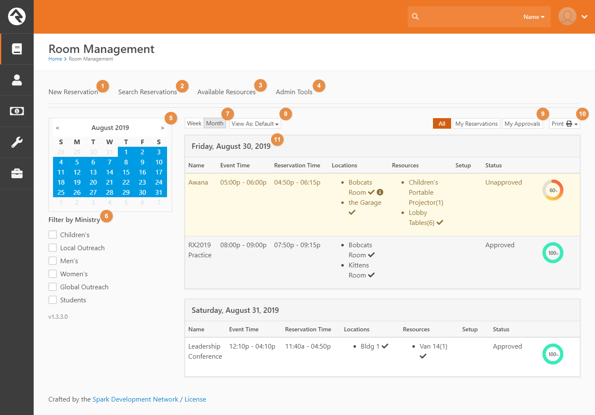

1. **New Reservation:** This takes you to the Reservation Detail page where you can create new reservations. For more information, see the *Reservation Detail Page*.
2. **Search Reservations:** This page allows you to find specific reservations. See the *Search Reservations Page* for more detail.
3. **Available Resources:** If you have a specific time you’d like to have an event, this page allows you to find available locations or resources for it. For more information, see the *Available Resources Page*.
4. **Admin Tools:** This page contains links to the Room Management configuration pages and is only visible to people in the **Room Management Administration** or **Rock Administration** security roles.
5. **Calendar:** Allows you to easily select dates to view reservations for. You can choose to hide or show the calendar, as well as what day the week starts on, via block settings.
6. **Filters:** While the Ministry filter is the only one shown here, there are a variety of filters available for use, including resource, location, and approval status. You’re able to configure which ones are shown and how in the block settings.
7. **View Mode:** Here you can switch between viewing reservations for the day, week, month, or even year. While Rock will remember which mode you last used, you can set the default mode, as well as which options are available, in the block settings.
8. **Reservation Views:** 1.4.0 now includes the ability to switch between different views on the main page. This expands the previous versions’ lava template settings. This allows you to, for example, create a calendar view and switch between it and the default list view. Much like Printable Reports, you can configure which ones you see in the block settings and configure the views themselves on the Reservation Views page under Admin Tools. You can switch between them using the dropdown shown here. If only one option is configured to be selectable, the dropdown will be hidden, and the view defaulted to that one view.
9. **My Reservation Toggle:** Allows the user to switch between viewing all reservations, ones they created / are a contact for, or ones that they are part of the approval process for.
10. **Printable Reports:** 1.4.0 also allows you to print PDF reports using multiple configurable templates, both ones that come out of the box or ones that you or another developer have created. These can be selected using this dropdown. You can configure which reports are selectable in the block settings, and add or modify the reports themselves on the Printable Reports page under Admin Tools.

Let’s take a closer look at the registrations when they’re displayed using the default Reservation View. To view or edit any reservation, simply click on its row.

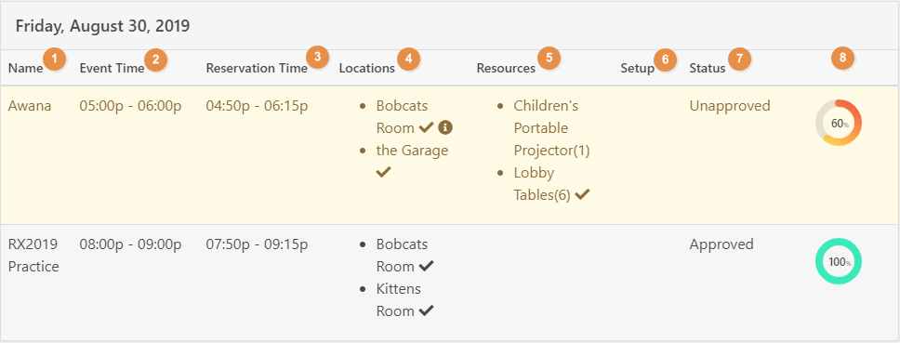

1. **Name:** The event’s name.
2. **Event Time:** The time the event will happen.
3. **Reservation Time:** The time that the locations and resources are to be reserved. It includes both the event time and setup/cleanup times.
4. **Locations:** The locations the reservation will use. Approved items are shown with a checkmark. Locations with Layouts tied to them will have and info circle next to them. Hovering over the circle will display a tooltip giving details about the layout.
5. **Resources:** Any resources that will be used, with the quantity reserved in parenthesis. Approved items are shown with a checkmark.
6. **Setup:** If a reservation has a setup diagram/photo, a thumbnail will appear here.
7. **Status:** The approval status of the request. Unapproved reservations appear in warning-yellow.
8. **Approval Indicator:** This is a visual indicator of how close the reservation is to being fully approved. When you hover or click on the indicator it will show you which group needs to approve each location or resource. The group name is a link to the group for quick access in case you want to fire off an email from Rock.

## Reservation Detail Page

This page is where you can add, edit, and approve reservations. When you hit Save on a reservation, the block will churn through the locations and resources you’ve requested and alert you to any that are already booked for the times you’ve requested.

### View Mode

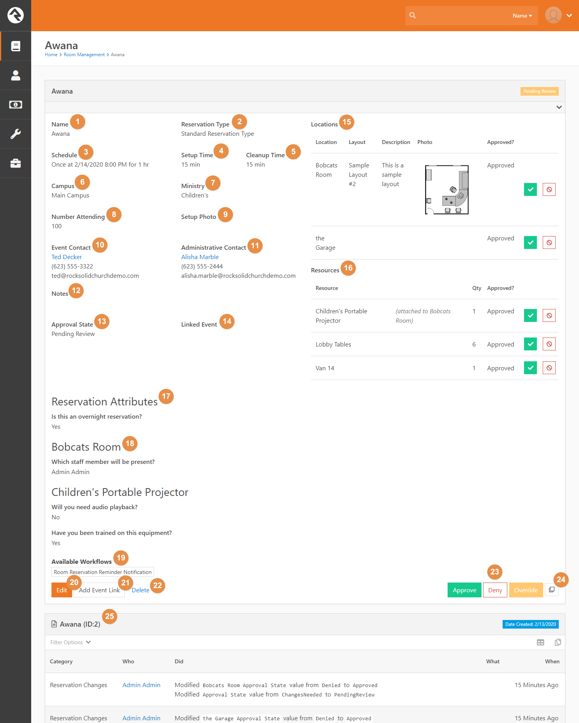

### Edit Mode

1. **Event Name:** The name of the event that you are reserving locations / resources for.
2. **Reservation Type:** The type of reservation this is for. Typically, you’ll just use the standard, but you can create and use your own like ‘Blackout’ types or ‘Maintenance’ types.
3. **Schedule:** The event’s schedule. Whenever this or the setup / cleanup times are changed, the Location and Resource pickers are set to grey out any locations or resources that are unavailable for those times.
4. **Set up Time:** The amount of time in minutes it will take to physically set up for the event.
5. **Clean up Time:** The amount of time in minutes it will take to tear down the event.
6. **Campus:** The campus that the reservation is associated with.
7. **Ministry:** The ministry that is reserving the locations / resources. You can add to or edit the list of ministries shown here in the Admin Tools.
8. **Number Attending:** The number of people you expect to attend this event.
9. **Setup Photo:** An optional photo/image showing the room setup for the event.
10. **Event Contact:** Details about who will be on site during the event.
11. **Administrative Contact:** Details on who should be contacted if there are questions about this event.
12. **Notes:** Any additional notes go here.
13. **Status:** The status of the event. By default, this is set to ‘Approved’ unless the location or room has an approval group or if a final approval group is setup (See Security/Approvals for details).
14. **Linked Event:** (view mode)If you have an event tied to your reservation, it’ll show up here.
15. **Locations:** Here you can select the locations and location layouts you want to reserve for your event. Any locations already reserved for the time slot you have selected will be greyed out. When you choose to add or edit a location, this modal will appear:

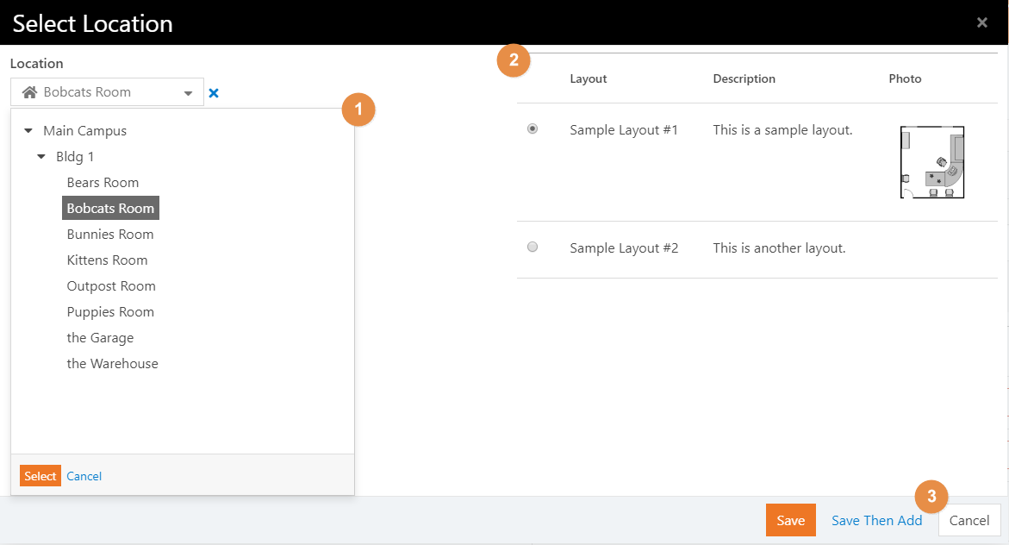

* 1. **Location:** Any reserved locations will be greyed out.
  2. **Layout:** If the location has any layouts, they’ll be displayed here for selection. Selecting a layout is optional.
  3. **Save Then Add:** If you’re adding a lot of resources and locations, click this button to keep the modal open and continue adding new items.

1. **Resources:** Here you can select the resources and quantities of those resources that are reserved for the event. When you choose to add or edit a resource, this modal will appear:

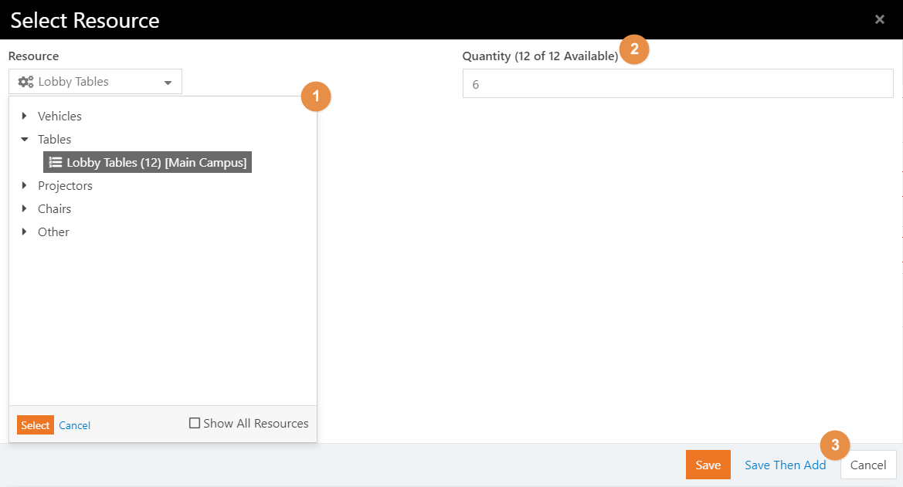

1. **Resource:** Any available resource will have the quantity available shown in parenthesis and any reserved resources will be greyed out.
2. **Quantity:** The amount of that resource you want to reserve.
3. **Save Then Add:** If you’re adding a lot of resources and locations, click this button to keep the modal open and continue adding new items.
4. **Reservation Attributes:** Any attributes configured on the reservation type will appear here.
5. **Additional Questions:** If any resources or locations being reserved have additional questions configured, they will be displayed here.
6. **Available Workflows:** Any workflows configured to be fired manually on the reservation type will appear here.
7. **Edit:** (view mode) Click this button to edit the reservation
8. **Add Event Link:** (view mode) If you want to tie your reservation to an event, click this button to start the process. For further information see the *Linking Events* section below
9. **Delete:** (view mode) Click this to delete the reservation
10. **Approval Buttons:** (view mode) As of 1.5.0, approval buttons are now on the view mode to improve efficiency. When a reservation has a *Pending Review* status, Approve and Deny buttons will be available for the Final Approval Group. At any point, the *Override* button will be available for Super Admins to override the normal process and mark everything as approved ( See the *Approval Process* section for more information.
11. **Copy Reservation**: (view mode) This button will create a duplicate of the reservation for you to edit.
12. **Change History:** (view mode) Listed here are any changes made to the reservation since it was created.

### When Making Reservations

When selecting locations for a *future* reservation, grayed-out items typically indicate the location is already reserved – either directly or indirectly. For example, if an entire campus has already been reserved, all the buildings and rooms under that campus will be grayed-out. In this case, selecting a room will provide a message indicating where the reservation conflict exists.

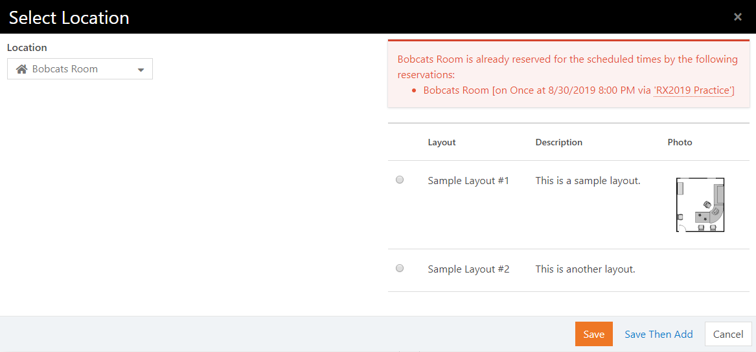

The conflicting event name(s) shown in the message can be clicked to view the details about each reservation.

Similarly, resources from other reservations that conflict with the schedule will be shown when adding or editing the resource.

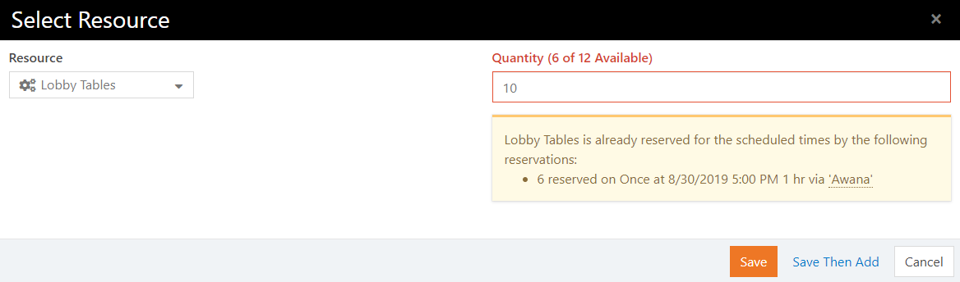

### Linking Events

In 1.5.0, you now can link events to your reservations. By default you can only link to existing event items, but you can change that in the block settings. We’ll be walking through creating our own event item. After clicking the ‘Add Event Link’ button, you’ll be taken to the page below to fill out Event Item information. This will auto populate with the reservation name, and photo if one exists.

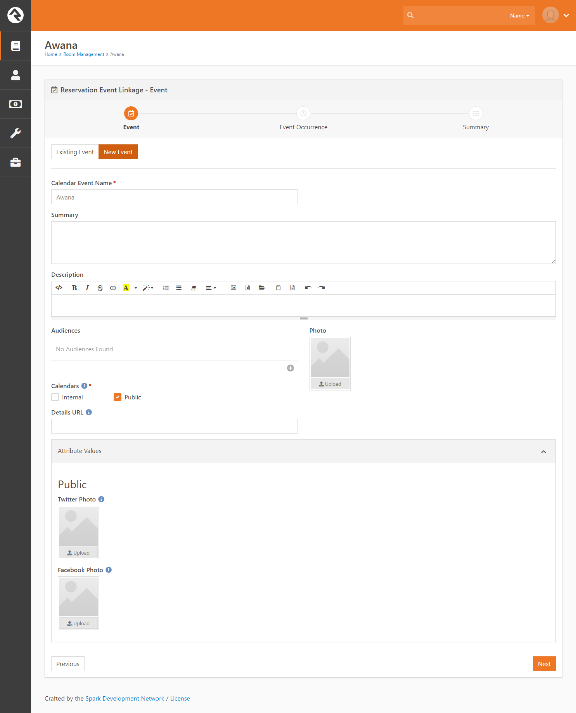

Next you’ll be taken to the Event Item Occurrence screen. This will auto populate the schedule and campus of the occurrence with the reservation’s values:

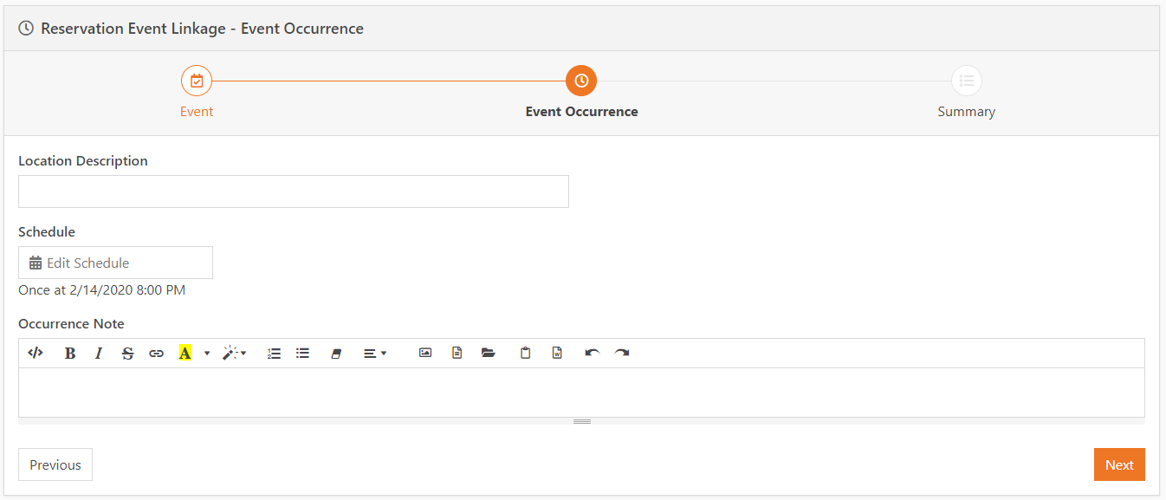

Then you’ll see a summary of the event you’re about to create:

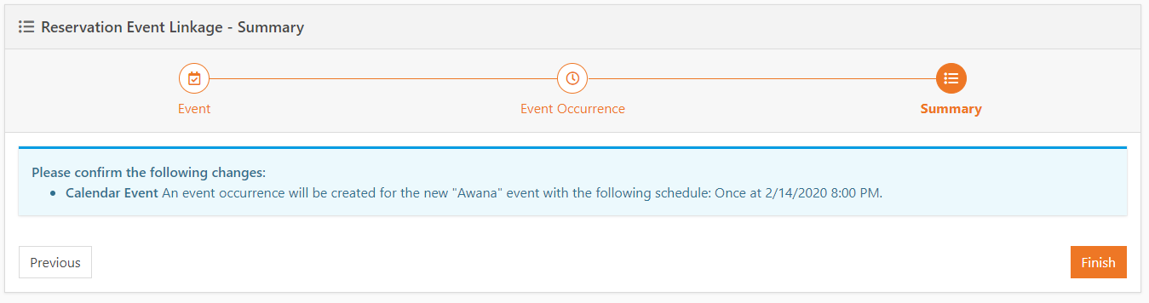

And finally links to the newly created items:

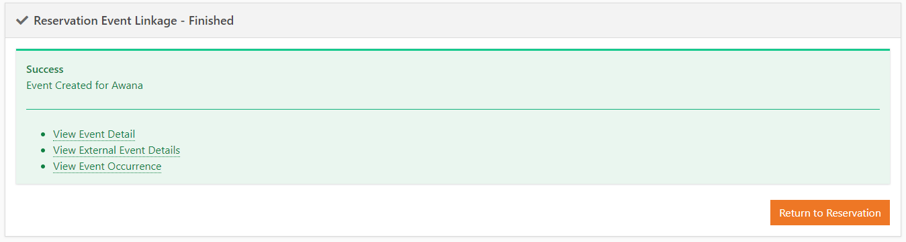

When viewing Event Details, you’ll be able to see a list of reservations tied to the occurrences:

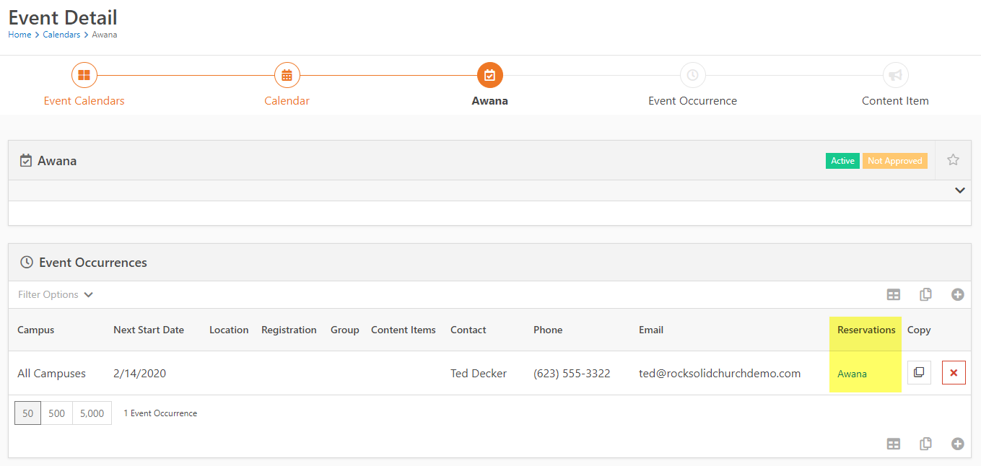

As well as see further details on the Occurrence Detail page:

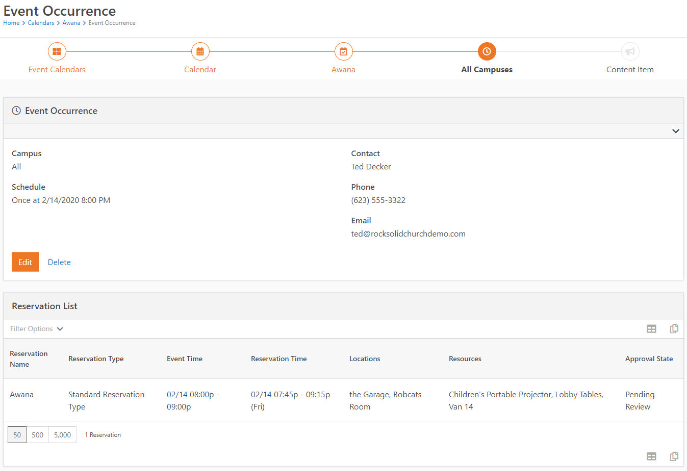

## Search Reservations Page

This page allows you to perform more advanced searches for the reservation you need than the main page allows for. You can search by time, name, type, ministry, resources or locations used, and even by creator. Once you find the reservation you’re looking for, simply click on the row and you’ll be directed to the detail page for that reservation.

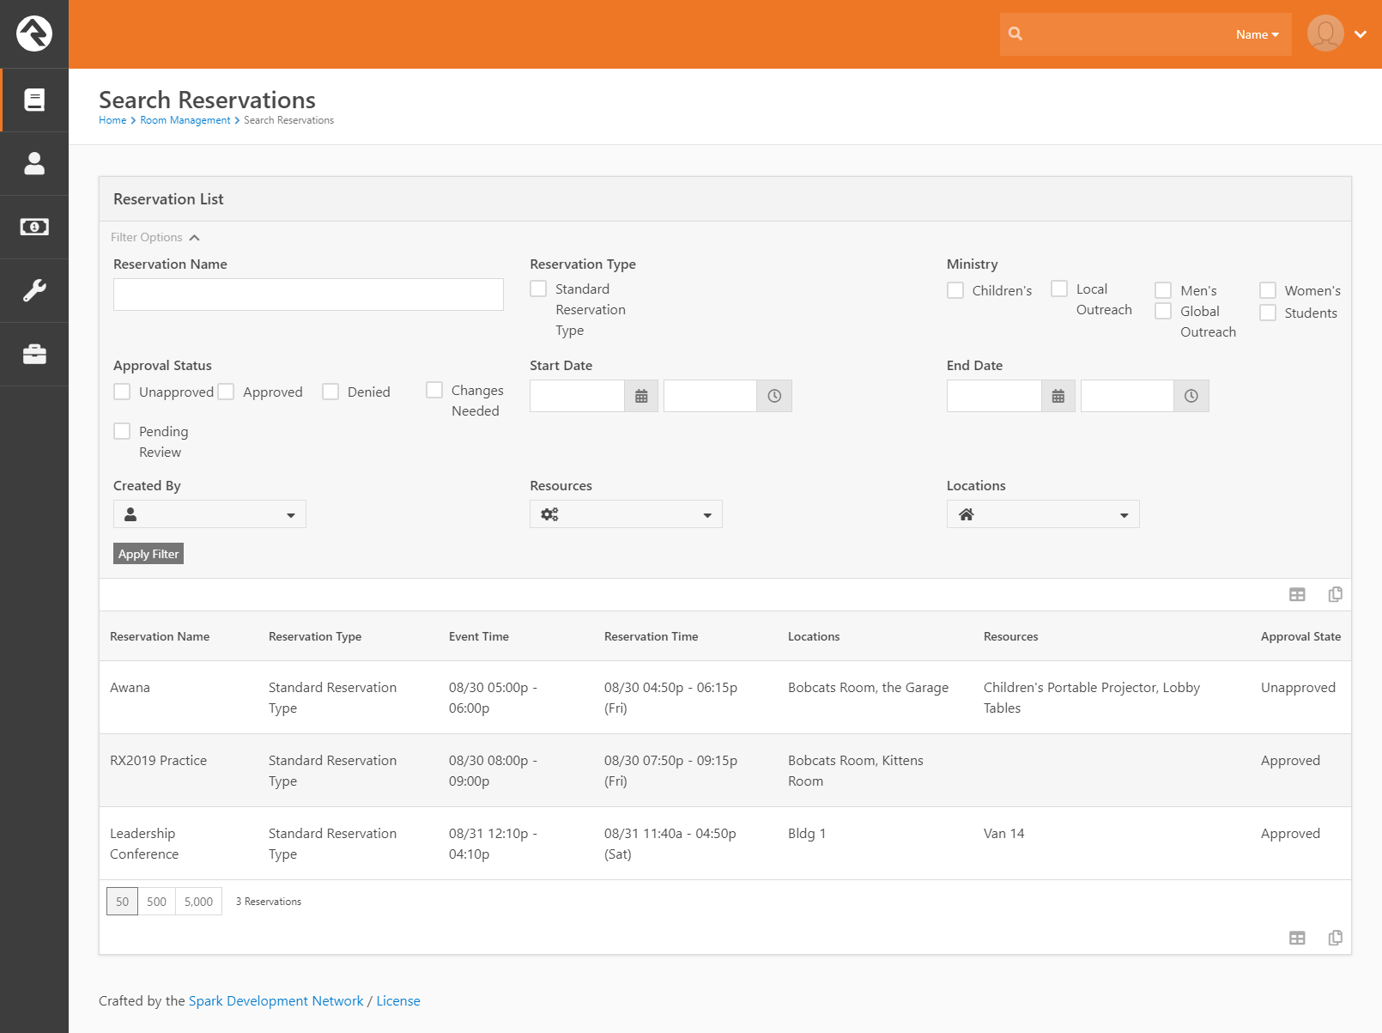

## Available Resources Page

On this page you can search for resources and locations that are available during your event time. Once you’ve found the resource or location that you need, simply click it and you’ll be directed to the New Reservation page with that resource or location already entered in.

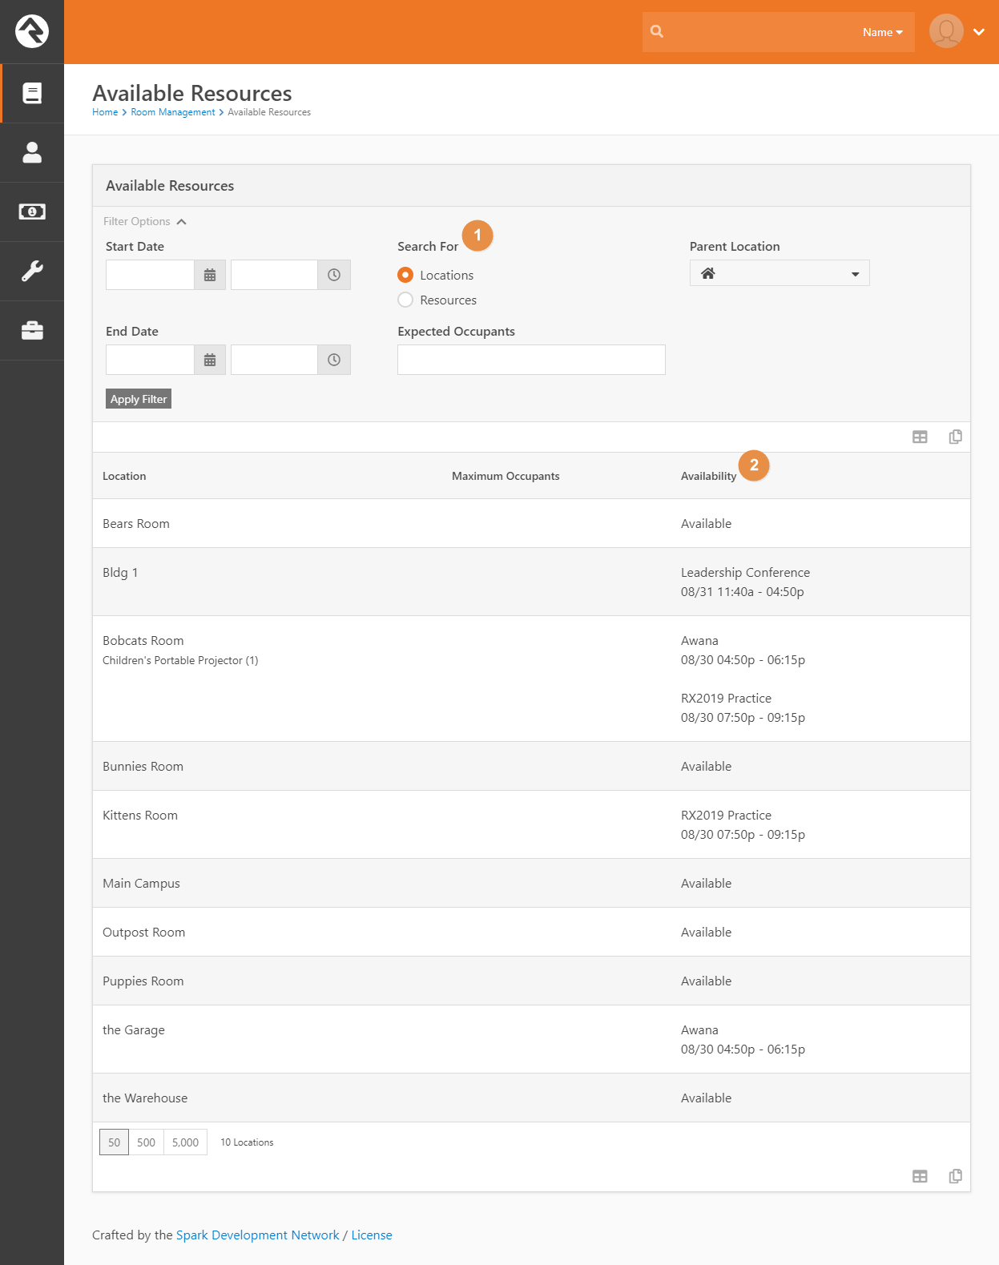

1. **Search For:** Here you can switch between searching for Resources and searching for locations.
2. **Availability:** This will display whether the Resource / Location is available, and how many are available in the case of Resources. If the item is reserved, this will display the reservation that has booked it.

## Admin Tools

Here is where you can edit how the Room Management system is set up.

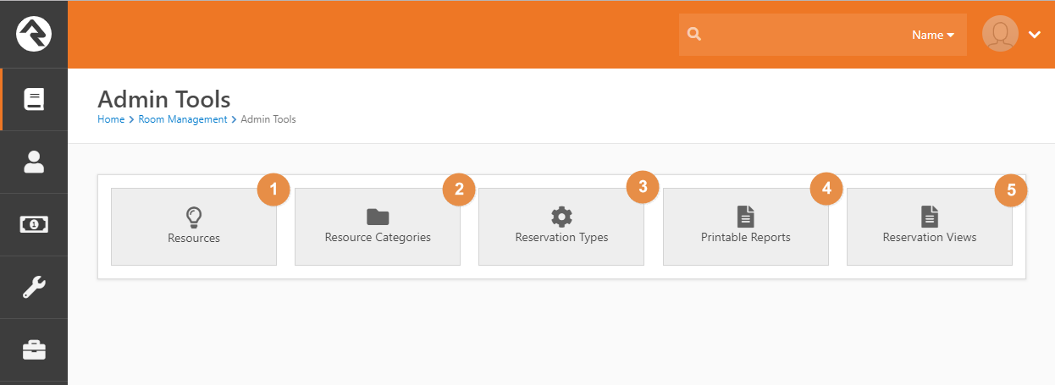

1. **Resources:** Here you can add and edit Resources to Rock.
2. **Resource Categories:** If you want to add, edit, or remove the categories used to sort resources, do so here.
3. **Reservation Types:** Here you can edit how the reservation types are set up.
4. **Printable Reports:** Here you can add and edit the available report templates used to print PDFs
5. **Reservation Views:** Here you can add and edit the available Reservation Views that determine how reservations are displayed on the main page.

## Resource Detail

This is the page where you’ll be adding or editing resources.

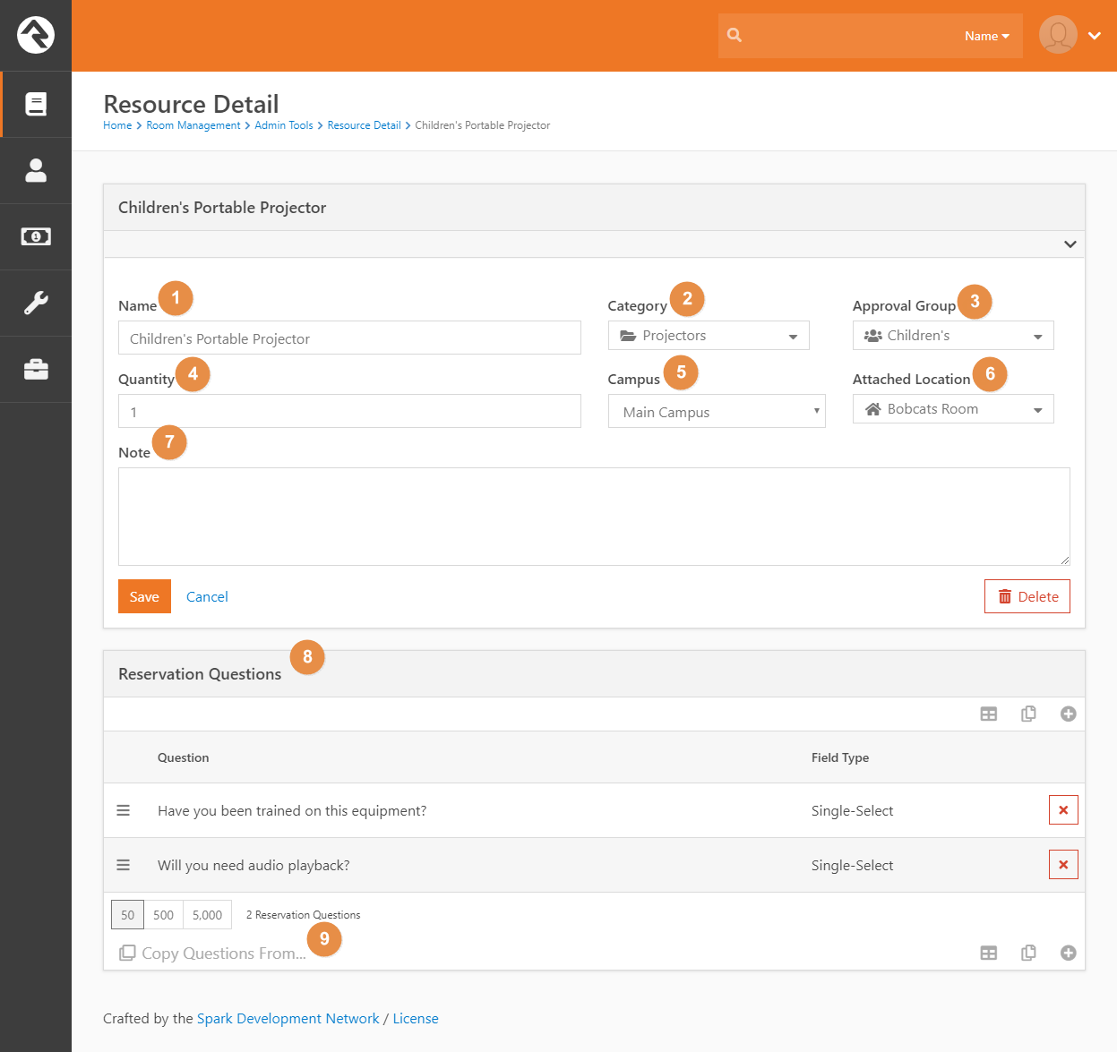

1. **Name:** The name of the resource.
2. **Category:** The category the resource falls under.
3. **Approval Group:** If this resource requires its own approval, add the group in charge of that here.
4. **Quantity:** The number of that resource that you have (e.g. ‘150 Gym Chairs).
5. **Campus:** If this resource is on a particular campus, specify the campus here.
6. **Attached Location:** If the resource is tied to a location, and can’t be moved from that location, specify that here.
7. **Notes:** Any additional notes on the resource go here.
8. **Reservation Questions:** Any additional questions you want answered when someone reserves this resource can be added here. You can specify what field type you would like the answer to be. Be sure to specify ‘Required’ if you want them to be required questions.
9. **Copy Questions From:** This button lets you copy a set of questions from another location or resource to this resource.

## Reservation Types

Here you can view and add to the configured Reservation Types. Most of the settings and configuration for reservations, including approval groups, ministries, and workflows, are set on the reservation type to allow for a more customizable experience.

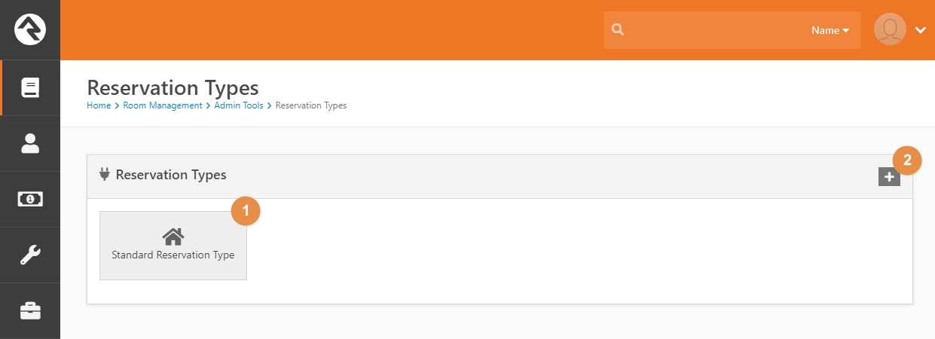

1. **Reservation Type:** Click here to view or edit this reservation type
2. **Add Reservation Type:** Click here to add another reservation type.

## Reservation Type Detail

Here you can fine-tune all the settings for your reservation types, as well as edit security for them. Editing security on a reservation type focuses on who can edit the reservations, and works as follows:

* **View Access:**  A user can only view these reservations
* **Edit Access:** A user can create reservations but can only edit reservations that they created or that they are the administrative contact for.
* **Administrate Access:** A user can edit any reservations of this type. By default, people in the Staff and Staff-Like Security Roles have this level of access.

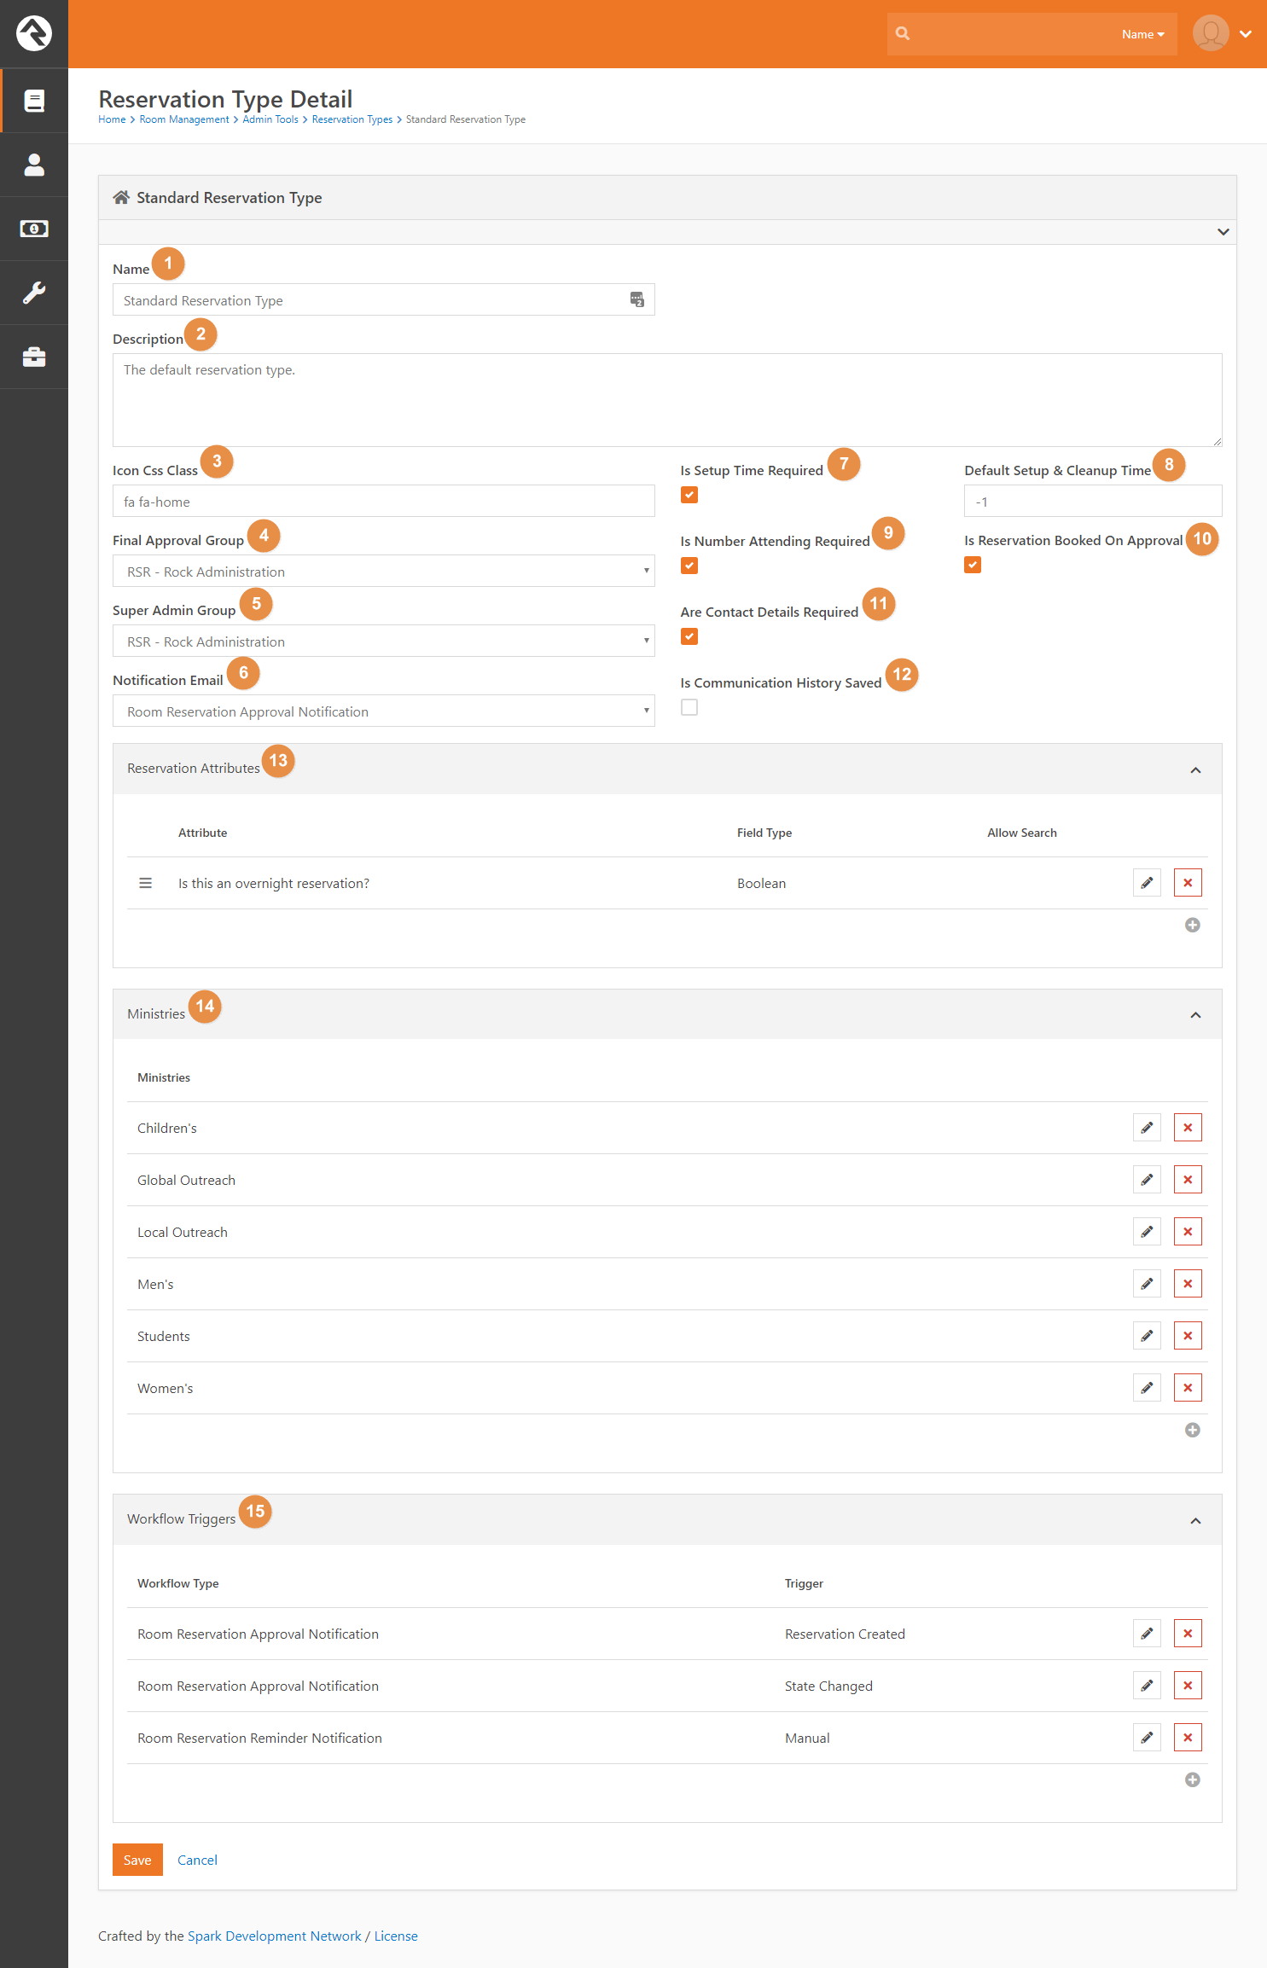

1. **Name:** The Reservation Type’s Name.
2. **Description:** The Reservation Type’s description.
3. **Icon Css Class:** The Font Awesome icon representing this Reservation Type.
4. **Final Approval Group:** If set, all reservations will require this group’s final approval. See the *Approval System* section for more information. People in this group will have edit access to all reservations of this type.
5. **Super Admin Group:** The group that can override all approval requirements. This typically is used by the facilities team for on-the-spot adjustments. For more information, see the *Approval System* section. People in this group will have edit access to all reservations of this type.
6. **Notification Email:** This is the email that gets sent to any approval groups tied to locations and resources on a reservation.
7. **Is Reservation Booked On Approval:** Normally, locations and resources are blocked out from being reserved by other reservations as soon as one is created, and held on to until the reservation is denied. This is a first-come-first-serve system, so we added a new feature that only reserves them after the reservation is approved. To ensure no conflicts, the following messages will be displayed at the top of the reservation if any occur:

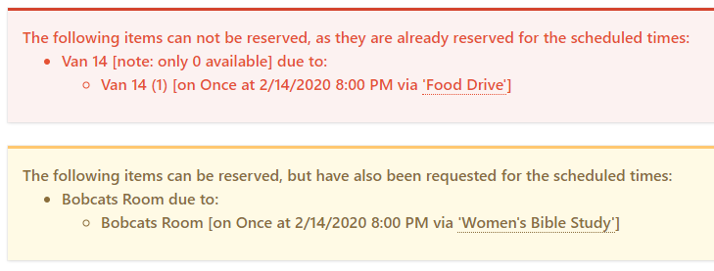

* + The Red notification box will list all locations / resources that are part of an approved reservation, and need to be removed from yours
  + The Yellow notification box lists other unapproved reservations that want to book the same location / resource for the same time. This is mostly for the benefit of the Final Approval Team.

1. **Is Communication History Saved:** Determines whether any approval notifications will get saved to people’s profiles.
2. **Are Contact Details Required:** Whether the Event Contact and Administrative Contact details are required.
3. **Reservation Attributes:** Here you can edit any additional fields you want on all of your reservations.
4. **Ministries:** Here you can edit the list of ministries you can choose from when creating a reservation. Oftentimes organizations use different ministry structures for different tasks, so here we allow you to customize the ministry list for reservations.
5. **Workflow Triggers:** If you want any workflows to fire off when events happen on a reservation, such as one being created or a status on one being changed, add them here. Room Management is shipped with ‘Reservation Created’ and ‘State Changed’ triggers tied to the *Room Reservation Approval Notification* workflow. These are used as part of the out-of-the-box approval flow.

## Location Detail

This is the Core Rock Location Detail page. On this page, we’ve added some new features:

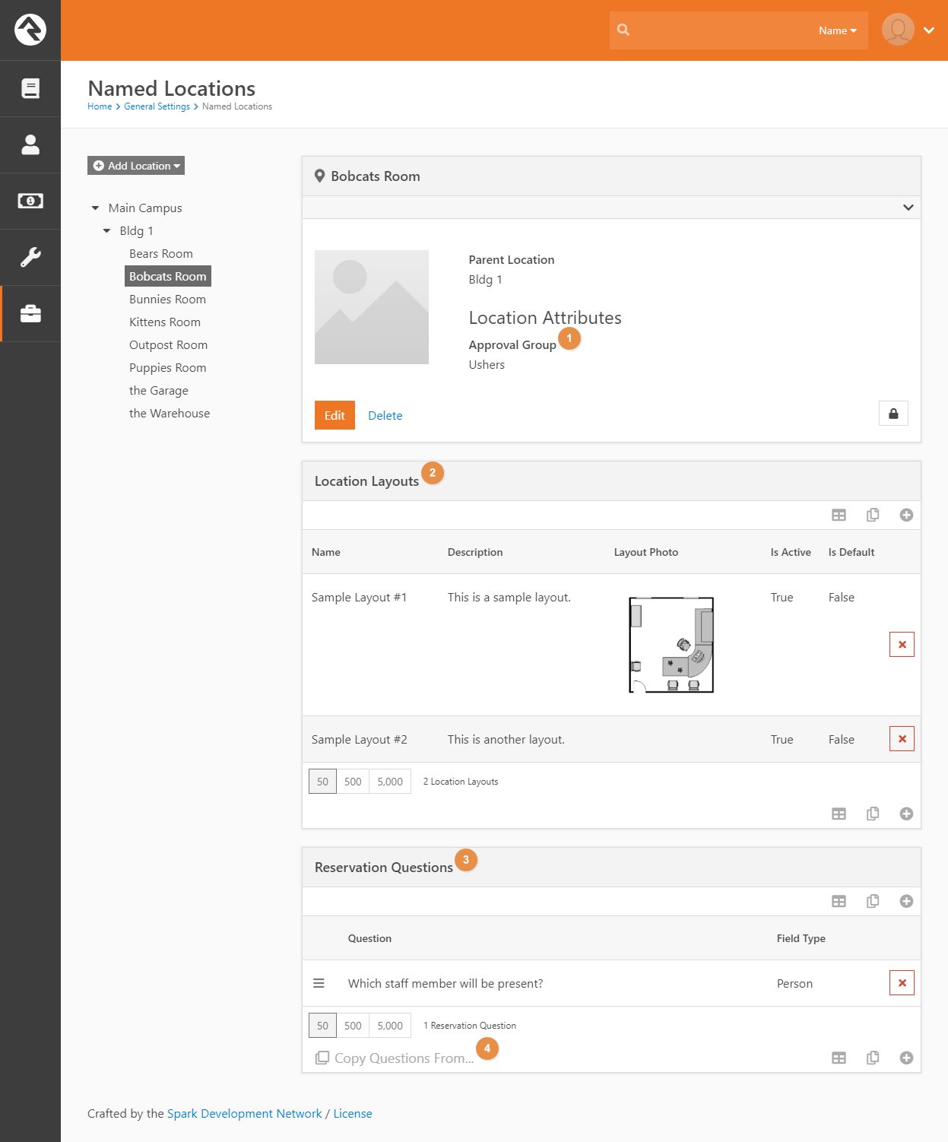

1. **Approval Group:** If this location requires its own approval, add the group in charge of that here.
2. **Location Layouts:** Here you can add or edit layouts to locations for selection on reservations. Be careful to only have one default layout if you are setting defaults, as the plugin will grab the first default layout there is.
3. **Reservation Questions:** Any additional questions you want answered when someone reserves this location can be added here. You can specify what field type you would like the answer to be. Be sure to specify ‘Required’ if you want them to be required questions.
4. **Copy Questions From:** This button lets you copy a set of questions from another location or resource to this location.

## Printable Reports

This page allows you to create new Printable Reports. These dictate what the PDFs that you print will look like. There are several configurable settings for the printable. For example, you can change the logo that appears in the printed reports. You can also choose which template to use when printing or create your own using the new Lava Template.

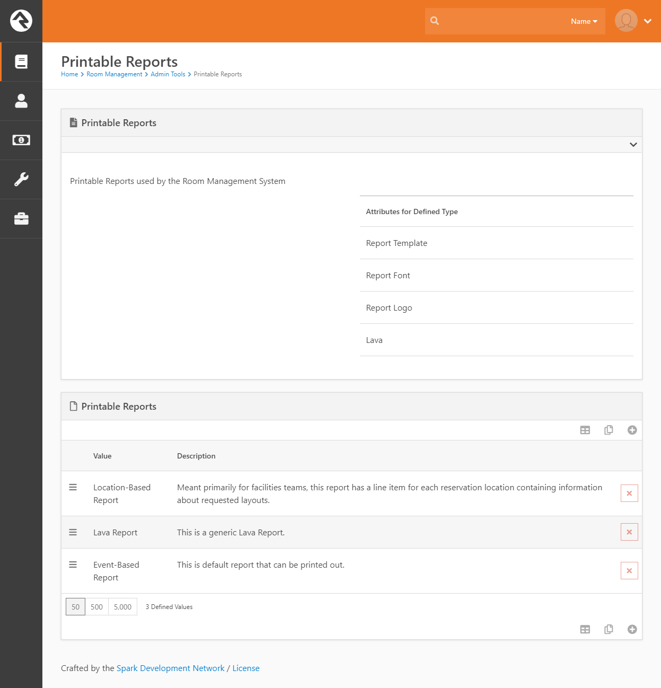

Each Printable Report consists of several Attributes:

1. **Report Template:** This is the template your report uses. For more information on this, take a look at the *Report Templates* section below. Generally if you’re creating your own Printable Report you’ll use the Lava Template.
2. **Report Font:** This is the font the report will use
3. **Report Logo:** This is the logo url the report will use
4. **Lava:** If you’ve selected the Lava Template, this is where you’ll place the lava that will be used.

## Reservation Views

This page allows you to create new Reservation Views. These dictate how reservations are displayed on the main page.

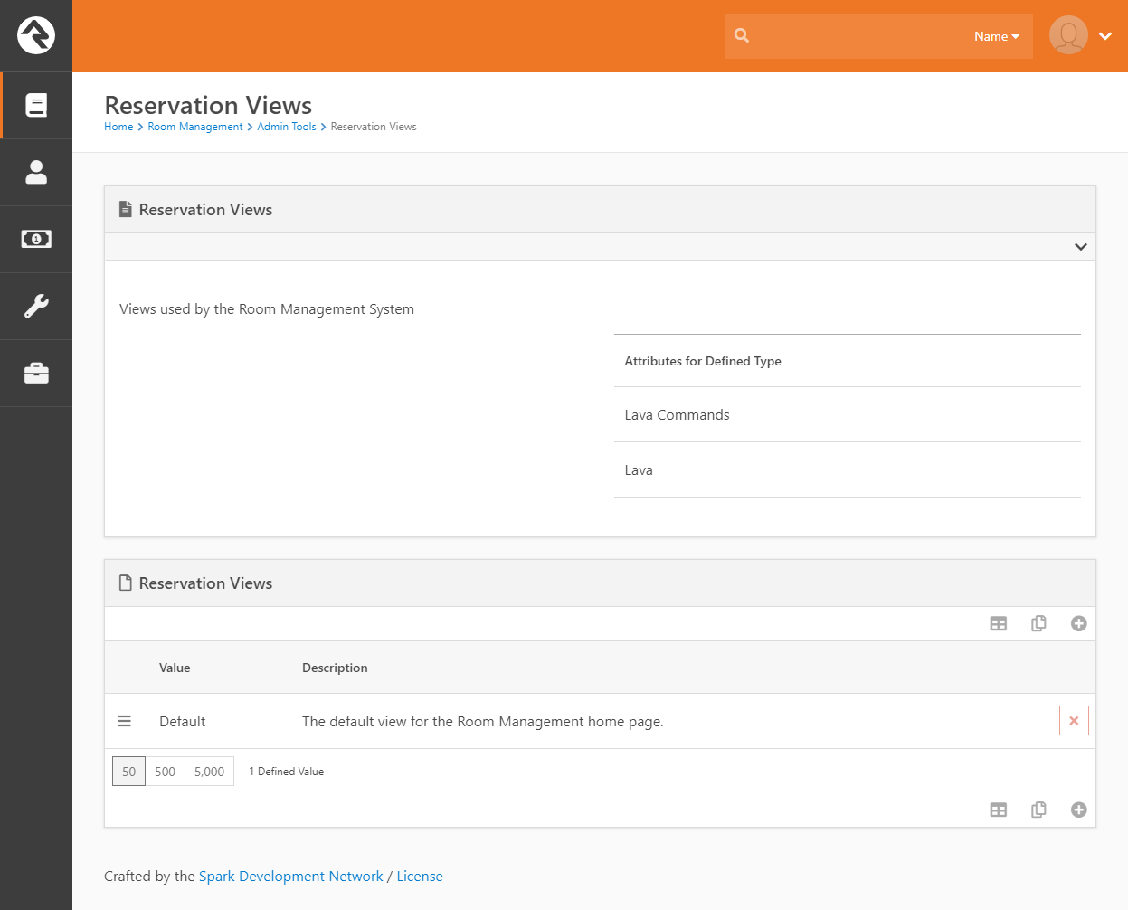

Each Printable Report consists of several Attributes:

1. **Lava Commands:** If your lava needs any special commands, set them here.
2. **Lava:** This is where you place the lava that dictates how the reservations are presented.

# Approval System

You should understand few more administrative details before you unleash your users on the new system. Namely, how the reservation *approval* system works.

## Approval Groups

Besides the basic security access used to grant your users to see the Resource Reservation system, three or four other groups control the approval process for reservations: Locations, Resources, Final Approval Group and Super Admin Group.

|  |  |
| --- | --- |
| Item | Description |
| Location (optional) | Each location can have a particular group responsible for controlling the approval of reservations using the location. This is configured via the new **Approval Group** setting on the *Location Detail* page. |
| Resource (optional) | Each resource can have a particular group responsible for controlling the approval of reservations using the resource. This can be configured via the **Approval Group** setting on the *Resource Detail* page. |
| Final Approval Group (optional) | If your organization always wants a particular group to perform the final approval of all reservations, the **Final Approval Group** setting on the **Reservation Type** controls this feature. |
| Super Admin Group (optional) | This setting on the **Reservation Type** controls the super-admin group that can force approve / deny status on reservations, such as a facilities team. |

**Note**: If a Final Approval Group is not set up, then Reservations without locations or resources that require special approval will be automatically approved if they do not conflict with existing reservations.

We recommend using the least restrictive settings, such as only putting Approval Groups on those locations and resources that absolutely must be approved by a person or group of people. However, we believe these configuration options give you the ability to set up more a more extensive approval system.

## Approval States

A reservation has five states that it can have during its life cycle:

* **Unapproved:** This is the default state of a reservation upon creation. Upon creation, Rock will search for any locations or resources that require special approval, and notify the configured approval groups. If no special approval is necessary, or if all items requiring it have been approved, the reservation moves to the Pending Review state. If any locations or resources that require special approval are denied, the reservation moves to the Changes Needed state. From this point on, any resources or locations booked by the reservation will be marked as ‘in use’ for that period.
* **Pending Review:** At this point, the reservation is waiting for final approval by the configured group. If they approve it, the reservation moves into the Approved state. If they decide the reservation is unrealistic and deny it, it moves into the Denied state. If they merely deny one or more resources or locations, then it moves into the Changes Needed state.  
  Note: If no Final Approval Group is configured, then the reservation will automatically move to the Approved state.
* **Changes Needed:** A reservation ends up in this state if individual resources or locations have been denied. After removing or changing them, the user can then resubmit the reservation, which will then return to the Unapproved state.
* **Approved:** This is the state a reservation will have once it’s been approved.
* **Denied:** A reservation that is denied will be hidden from the hub page, and any resources or locations booked by it will be marked as available for that time frame.

## Configured Workflows

Configured workflows also play a huge part in the approval process. By default, Room Management is shipped with ‘Reservation Created’ and ‘State Changed’ triggers tied to the Room Reservation Approval Notification workflow for the Standard Reservation Type. This workflow simply notifies relevant parties that the reservation requires their attention. If you wish to extend or build on the approval system, you can do so by expanding on these.

**Caution!**   
If you want to make changes to these workflows, we recommend you make a copy of these stock workflows and make your changes there. When finished, simply add your new workflow triggers (under Room Management | Admin Tools | Reservation Configuration) and remove the ones that came shipped with the plugin. Otherwise, you could have problems with a future plugin update that needs to modify the stock workflows.

# System Jobs

## Fire Workflow from Reservation in Date Range

Included in the plugin is a system job that will fire off a workflow for each reservation in a date range (of a given approval state). By setting the date range equal to the job’s schedule, this job can be used as a notification service for upcoming reservations. For example, the plugin comes included with one such job called “Reservation Reminder” which can be configured to run once a day and fires the Room Reservation Reminder Notification workflow for each approved reservation that begins that day.

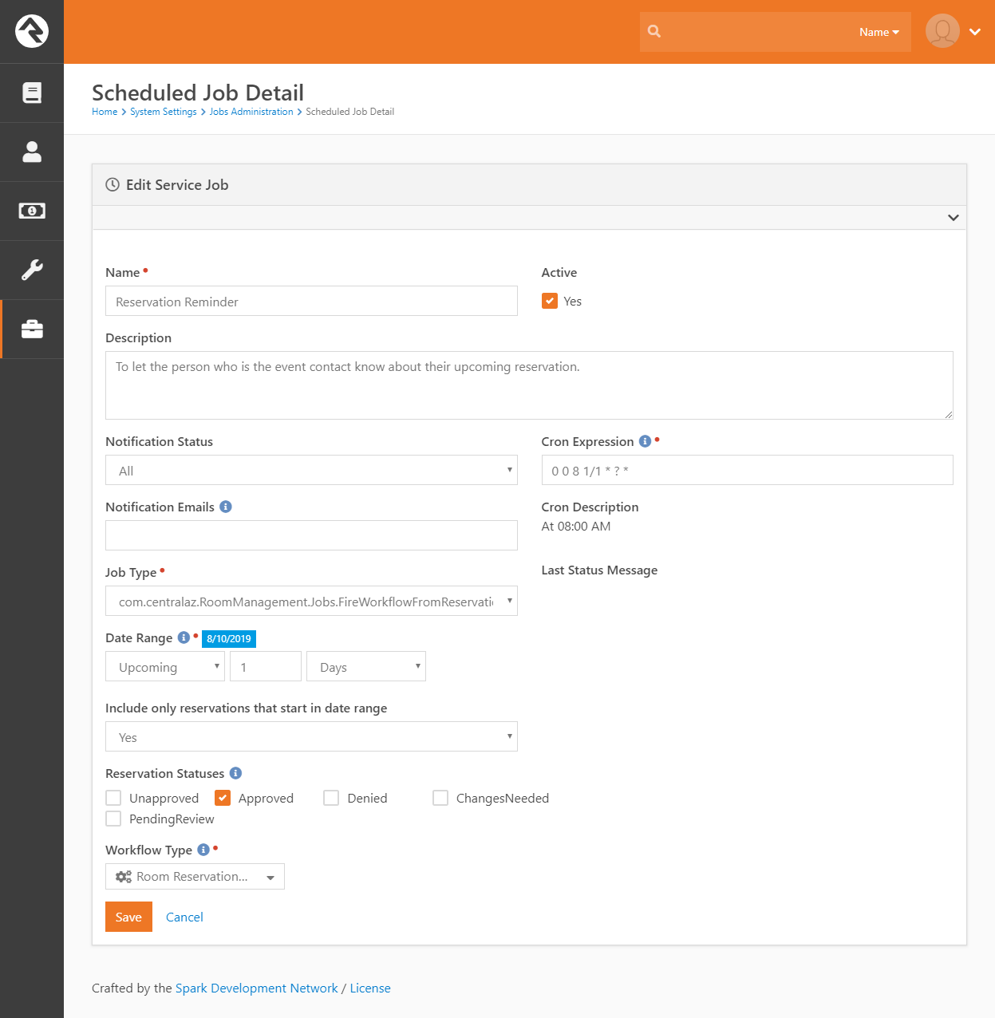

Note: By default, grabbing reservations within a date range will also return reservations that began previously, but extend into that date range. If you only want to return reservations that begin in the date range, be sure to check the ‘Include only reservations that start in date range’ button.

# Workflow Types

## Room Reservation Approval Notification

This is a simple workflow tied to the approval process. Based on the state of the reservation, the workflow will either notify the *Final Approval Group* (dictated by the Reservation Type) that a reservation requires their approval or notify the requestor that their reservation has been approved, denied, or requires changes.

## Room Reservation Reminder Notification

This workflow is fired from the ‘Fire Workflow from Reservation in Date Range’ (Reservation Reminder) job described above, and sends an email to the Event Contact that a reservation they are in charge of is occurring that day.

# Report Templates

Included in the plugin are several Report Templates that you can use for creating Printable Reports. You can also create your own custom templates to use by following the format in the files here: <https://github.com/CentralAZ/Rock-CentralAZ/tree/central-develop/com.centralaz.RoomManagement/ReportTemplates>

## Default Template

This will be the standard template most churches are familiar with. It contains a row for each reservation occurrence along with standard rows that mirror the default hub reservation list.

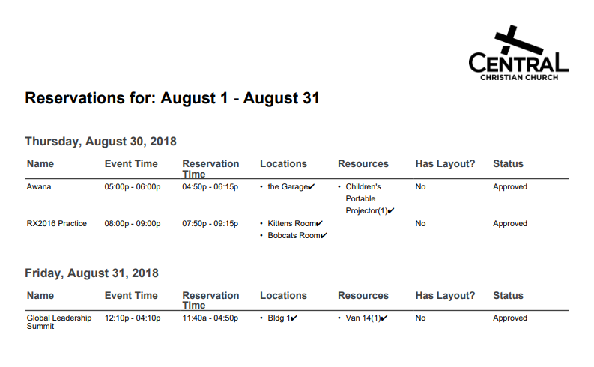

## Advanced Template

This template is geared heavily towards facilities teams, with the reservations broken up so that there is a location on each row. Resources are removed, and contact info has been included. Page counts are now included, as will as the date at the top of the page if a single day goes longer than a page.

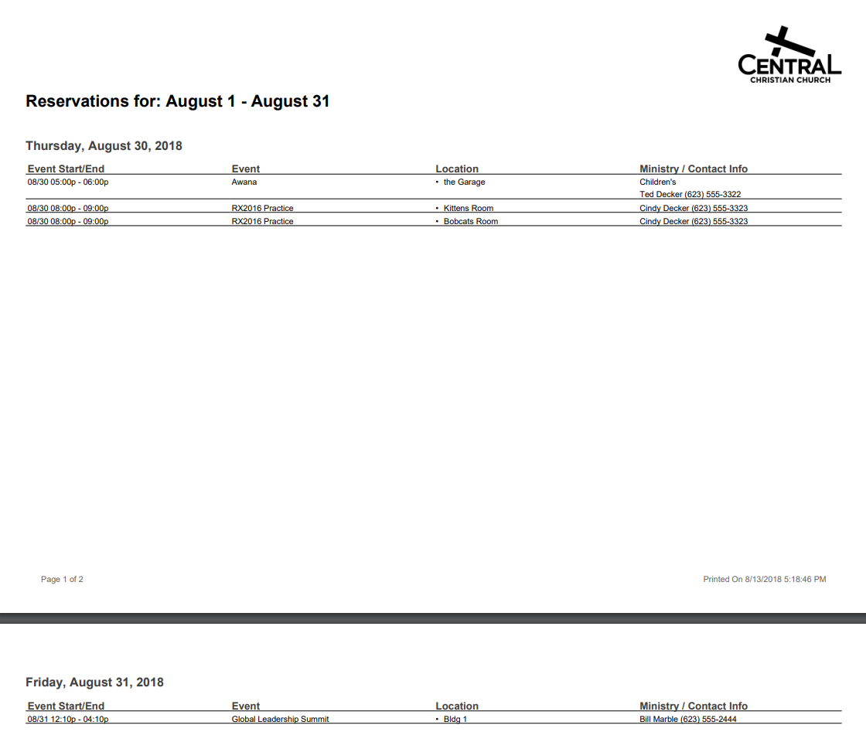

## Lava Template

Using a simpler, free library that enables html-to-pdf functionality, we’ve created a lava template that you can customize to your individual need. Simply paste your code into the Printable Report’s *Lava* attribute and select the ‘Lava Template’ option on the *Report Template* Attribute.

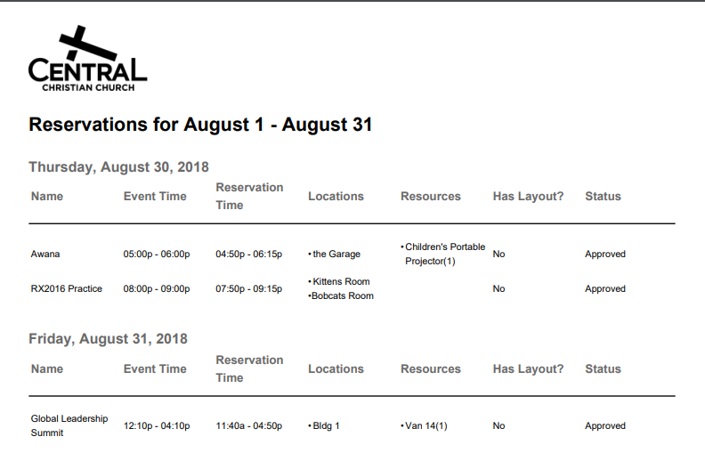

# Data Filters

Included in the plugin is a data filter that will filter reservations based off their approval state and a date range. You can use this to build custom Data Views and Reports for your own needs.

**Note**: By default, grabbing reservations within a date range will also return reservations that began previously, but extend into that date range. If you only want to return reservations that begin in the date range, be sure to check the ‘Include only reservations that start in date range’ button.

You are all set! Now you are ready to start using the Room & Resource Reservation Plugin. Just remember to do the things recommended in the next section, Initial Setup.

# Initial Setup

Once you have a good idea of how the system works, these are the things you should begin adjusting to meet your needs.

Note: If this is the first time you’ve installed this plugin, you may need to restart Rock once in order for our Lava entities to register – otherwise you may see something like “Lava error, unknown entity” on your Event Detail in the Event Occurrences section/panel.

Under Admin Tools…

1. Edit the Resource Categories and add any you think are missing
2. Edit the Standard Reservation Type
   1. Add the ministries that work for your organization.
   2. Set a Final Approval Group, but only if your organization operates this way. You can also set the Super Admin Group if you want a particular team (such as your facilities team) to be able to force approve/deny reservations. See the *Approval Groups* section under Administration for details about these two settings.
3. Edit the Resource List and add all the resources for each campus. Do not make it too noisy; just add the ones that make sense from a reservation perspective.
   1. Remember to set an *Approval Group* for the resource if a special team needs to approve it before it can be reserved.
   2. Remember to set the *Attached Location* if the resource is a permanent, unmovable item.

On the main page…

1. Change the Block Properties to suit your needs. There are options for showing additional filters such as a campus filter, ministry filter, etc.

Under Rock’s General Settings | Named Locations…

1. Edit your organizations rooms and set an *Approval Group* if a special team is required to approve the rooms use before it can be reserved.
2. Add any Location Layouts that are needed.

Under Rock’s General Settings | Global Attributes…

1. Edit the *Default Enabled Lava Commands* and make sure that **Execute** is checked. This is needed for the Room Reservation Reminder Notification. If you don’t enable this, you will see a lava error in the schedule line of the email notice.

**Note**: If you really object to this, then you will need to remove the “{% execute… %} … {% endexecute %}” section from Body of the email in the Workflow’s Send Email action. However you will lose the Event Duration value in the email.

# Reporting Bugs

If you run into a bug that you would like to report, please do so on the CentralAZ Issues page: <https://github.com/CentralAZ/Rock-CentralAZ/issues>

Simply prefix your issue with “[RR]” for Resource Reservation.

# Developer Appendixes

## API Calls

## ~/api/Reservations/GetReservationOccurrences

This is an API call to get individual occurrences of Reservations, returned in the form of ReservationOccurrences. It includes the following optional parameters:

* DateTime? startDateTime
  + Filters occurrences that occur during or after the specified date
  + Defaults to current datetime
* DateTime? endDateTime
  + Filters occurrences that occur during or before the specified date
  + Defaults to current datetime plus one month
* String reservationTypeIds
  + Filters occurrences by reservation type
  + Should be a list of integers separated by commas
  + Defaults to null
* String reservationIds
  + Filters occurrences by reservation
  + Should be a list of integers separated by commas
  + Defaults to null
* String locationIds
  + Filters occurrences by location
  + Should be a list of integers separated by commas
  + Defaults to null
* String resourceIds
  + Filters occurrences by resource
  + Should be a list of integers separated by commas
  + Defaults to null
* String approvalStates
  + Filters occurrences by approval state
  + Should be a list of strings separated by commas
  + Defaults to ‘Approved’

The API call will return a list of ReservationOccurrences, a class specifically created for this API call that contains the following properties:

* Int ReservationId
* ReservationType ReservationType
* ReservationApprovalState ApprovalState
* String ReservationName
* List<ReservationLocation> ReservationLocations
* List<ReservationResource> ReservationResources
* DateTime ReservationStartDateTime
* DateTime ReservationEndDateTime
* DateTime EventStartDateTime
* DateTime EventEndDateTime
* Int? SetupPhotoId
* String Note
* Int? NumberAttending
* DateTime? ModifiedDateTime
* Int? ScheduleId

## Entity Relationship Diagram

